**ASSIGNMENT NO. 02**

**NAME: LAIBA IQBAL**

**CLASS: BSE-(6B)**

**ENROLLMENT: 02-131192-054**

WEB ENGINEERING

**COURSE CODE: ( SEN – 310 )**

* **Question No. 01: [CLO3: 5 Marks]**

**Using the knowledge gained by learning and implementing HTML5, CSS, Boostrap, Flexbox and Javascript Basics. The color themes and good concepts should be visible on your website and fully responsive. Submission must include the following:**

1. **Html5 Script**
2. **CSS/Flexbox Script**
3. **Javascript**
4. **Boostrap**
5. **Zip files for all the Scripts**
6. **Screenshot of your website**

* **Solution:**

**“HTML5 SCRIPT”**

* **index.html:**

<!DOCTYPE html>

<html lang="en">

<head>

    <meta charset="UTF-8">

    <meta http-equiv="X-UA-Compatible" content="IE=edge">

    <meta name="viewport" content="width=device-width, initial-scale=1.0">

    <title>Cafena Coffee Shop</title>

    <!-- font awesome cdn link  -->

    <link rel="stylesheet" href="https://cdnjs.cloudflare.com/ajax/libs/font-awesome/5.15.4/css/all.min.css">

    <!-- custom css file link  -->

    <link rel="stylesheet" href="css/style.css">

</head>

<body>

<!-- header section starts  -->

<header class="header">

    <a href="#" class="logo">

        <img src="images/logo.png" alt="">

    </a>

    <nav class="navbar">

        <a href="#home">home</a>

        <a href="#about">about</a>

        <a href="#menu">menu</a>

        <a href="#products">products</a>

        <a href="#review">review</a>

        <a href="#contact">contact</a>

        <a href="#blogs">blogs</a>

    </nav>

    <div class="icons">

        <div class="fas fa-search" id="search-btn"></div>

        <div class="fas fa-shopping-cart" id="cart-btn"></div>

        <div class="fas fa-bars" id="menu-btn"></div>

    </div>

    <div class="search-form">

        <input type="search" id="search-box" placeholder="search here...">

        <label for="search-box" class="fas fa-search"></label>

    </div>

    <div class="cart-items-container">

        <div class="cart-item">

            <span class="fas fa-times"></span>

            <img src="images/cart-item-1.png" alt="">

            <div class="content">

                <h3>cart item 01</h3>

                <div class="price">$15.99/-</div>

            </div>

        </div>

        <div class="cart-item">

            <span class="fas fa-times"></span>

            <img src="images/cart-item-2.png" alt="">

            <div class="content">

                <h3>cart item 02</h3>

                <div class="price">$15.99/-</div>

            </div>

        </div>

        <div class="cart-item">

            <span class="fas fa-times"></span>

            <img src="images/cart-item-3.png" alt="">

            <div class="content">

                <h3>cart item 03</h3>

                <div class="price">$15.99/-</div>

            </div>

        </div>

  <div class="cart-item">

            <span class="fas fa-times"></span>

            <img src="images/cart-item-4.png" alt="">

            <div class="content">

                <h3>cart item 04</h3>

                <div class="price">$15.99/-</div>

            </div>

        </div>

        <a href="#" class="btn">checkout now</a>

    </div>

</header>

<!-- header section ends -->

<!-- home section starts  -->

<section class="home" id="home">

    <div class="content">

        <h3>Fuel for your creativity</h3>

        <p>Where “Made Well” matters !! <br> To inspire and nurture the human spirit – one person, one cup, and one neighborhood at a time</p>

        <a href="#" class="btn">get yours now</a>

    </div>

</section>

<!-- home section ends -->

<!-- about section starts  -->

<section class="about" id="about">

<h1 class="heading"> <span>about</span> us </h1>

    <div class="row">

        <div class="image">

            <img src="images/about-img.jpeg" alt="">

        </div>

        <div class="content">

            <h3>what makes our coffee special?</h3>

            <br>

            <p>The Cafena Coffee Shop offers the finest speciality coffee taking into account the origins of the speciality coffee beans, ethical standards and by calling uppon the expertise of master coffee roasters.</p>

            <p>Our Coffee quality is beyond the final product served on your cup. Its quality springs from the start—the type of coffee beans grown, the region, roasting, and brewing, down to the actual coffee served right under your nose. </p>

            <a href="#" class="btn">learn more</a>

        </div>

    </div>

</section>

<!-- about section ends -->

<!-- menu section starts  -->

<section class="menu" id="menu">

    <h1 class="heading"> our <span>menu</span> </h1>

    <div class="box-container">

        <div class="box">

            <img src="images/menu-1.png" alt="">

            <h3>Espresso</h3>

    <div class="price">Rs.1000 <span>1500.00</span></div>

            <a href="#" class="btn">add to cart</a>

        </div>

        <div class="box">

            <img src="images/menu-2.png" alt="">

            <h3>Americano</h3>

            <div class="price">Rs.600 <span>1000.00</span></div>

            <a href="#" class="btn">add to cart</a>

        </div>

        <div class="box">

            <img src="images/menu-3.png" alt="">

            <h3>Cappuccino</h3>

            <div class="price">Rs.800 <span>1200.00</span></div>

            <a href="#" class="btn">add to cart</a>

        </div>

        <div class="box">

            <img src="images/menu-4.png" alt="">

            <h3>Latte</h3>

            <div class="price">Rs.1500 <span>2000.99</span></div>

            <a href="#" class="btn">add to cart</a>

        </div>

        <div class="box">

            <img src="images/menu-5.png" alt="">

            <h3>Mocha</h3>

            <div class="price">Rs.1400 <span>1800.99</span></div>

            <a href="#" class="btn">add to cart</a>

</div>

        <div class="box">

            <img src="images/menu-6.png" alt="">

            <h3>Glacé</h3>

            <div class="price">Rs.2000 <span>2500.00</span></div>

            <a href="#" class="btn">add to cart</a>

        </div>

    </div>

</section>

<!-- menu section ends -->

<section class="products" id="products">

    <h1 class="heading"> our <span>products</span> </h1>

    <div class="box-container">

        <div class="box">

            <div class="icons">

                <a href="#" class="fas fa-shopping-cart"></a>

                <a href="#" class="fas fa-heart"></a>

                <a href="#" class="fas fa-eye"></a>

            </div>

            <div class="image">

                <img src="images/product-1.png" alt="">

            </div>

            <div class="content">

                <h3>Arabica</h3>

                <div class="stars">

    <i class="fas fa-star"></i>

                    <i class="fas fa-star"></i>

                    <i class="fas fa-star"></i>

                    <i class="fas fa-star"></i>

                    <i class="fas fa-star"></i>

                </div>

                <div class="price">Rs.1200 <span>Rs.1500</span></div>

            </div>

        </div>

        <div class="box">

            <div class="icons">

                <a href="#" class="fas fa-shopping-cart"></a>

                <a href="#" class="fas fa-heart"></a>

                <a href="#" class="fas fa-eye"></a>

            </div>

            <div class="image">

                <img src="images/product-2.png" alt="">

            </div>

            <div class="content">

                <h3>Robusta</h3>

                <div class="stars">

                    <i class="fas fa-star"></i>

                    <i class="fas fa-star"></i>

                    <i class="fas fa-star"></i>

                    <i class="fas fa-star-half-alt"></i>

    <i class="fas fa-star-half-alt"></i>

                </div>

                <div class="price">Rs.1500 <span>Rs.1800</span></div>

            </div>

        </div>

        <div class="box">

            <div class="icons">

                <a href="#" class="fas fa-shopping-cart"></a>

                <a href="#" class="fas fa-heart"></a>

                <a href="#" class="fas fa-eye"></a>

            </div>

            <div class="image">

                <img src="images/product-3.png" alt="">

            </div>

            <div class="content">

                <h3>Excelsa</h3>

                <div class="stars">

                    <i class="fas fa-star"></i>

                    <i class="fas fa-star"></i>

                    <i class="fas fa-star"></i>

                    <i class="fas fa-star"></i>

                    <i class="fas fa-star-half-alt"></i>

                </div>

                <div class="price">Rs.1800 <span>Rs.2000</span></div>

            </div>

  </div>

    </div>

</section>

<!-- review section starts  -->

<section class="review" id="review">

    <h1 class="heading"> customer <span>reviews</span> </h1>

    <div class="box-container">

        <div class="box">

            <img src="images/quote-img.png" alt="" class="quote">

            <p>I was super impressed by the quality of the environment and the coffee. We came here early in the morning, the staff was super helpful. This place had the best coffee we tasted in Pakistan so far it's more of a European style of cafe in terms of quality of service and beverages.</p>

            <img src="images/pic-1.png" class="user" alt="">

            <h3>john deo</h3>

            <div class="stars">

                <i class="fas fa-star"></i>

                <i class="fas fa-star"></i>

                <i class="fas fa-star"></i>

                <i class="fas fa-star"></i>

                <i class="fas fa-star"></i>

        </div>

    </div>

    <div class="box">

            <img src="images/quote-img.png" alt="" class="quote">

            <p>I visisted the branch near Maskan yesterday. We were greeted warm heartedly. Place is small but much clean. Free water as well as free wifi is available. Work station was also great. They import their coffee from apme coffee plantations in Brazil - not using any commercial brands.</p>

            <img src="images/pic-2.png" class="user" alt="">

            <h3>Naimal Khawar</h3>

            <div class="stars">

                <i class="fas fa-star"></i>

                <i class="fas fa-star"></i>

                <i class="fas fa-star"></i>

                <i class="fas fa-star-half-alt"></i>

                <i class="fas fa-star-half-alt"></i>

            </div>

        </div>

        <div class="box">

            <img src="images/quote-img.png" alt="" class="quote">

            <p>Attended a reunion here the proprietor being one of our colleagues..This place is fresh not like the overly done up places you are generally accustomed to..and it gives you a feeling of lightness, very calming. Also the good latte blend with roasted almonds dust makes it more mouth watering.</p>

            <img src="images/pic-3.png" class="user" alt="">

            <h3>jack wyatt</h3>

            <div class="stars">

                <i class="fas fa-star"></i>

                <i class="fas fa-star"></i>

    <i class="fas fa-star"></i>

                <i class="fas fa-star"></i>

                <i class="fas fa-star-half-alt"></i>

        </div>

        </div>

    </div>

</section>

<!-- review section ends -->

<!-- contact section starts  -->

<section class="contact" id="contact">

    <h1 class="heading"> <span>contact</span> us </h1>

    <div class="row">

        <iframe src="https://www.google.com/maps/embed?pb=!1m18!1m12!1m3!1d3621.935123334103!2d67.04308731423315!3d24.79767495387988!2m3!1f0!2f0!3f0!3m2!1i1024!2i768!4f13.1!3m3!1m2!1s0x3eb33d02bcbb3b29%3A0x51f1ed37ecbe3da5!2sStreet%205%2C%20D.H.A%20Phase%206%20Defence%20V%20Defence%20Housing%20Authority%2C%20Karachi%2C%20Karachi%20City%2C%20Sindh%2075500%2C%20Pakistan!5e0!3m2!1sen!2s!4v1651487889426!5m2!1sen!2s" width="600" height="450" style="border:0;" allowfullscreen="" loading="lazy" referrerpolicy="no-referrer-when-downgrade"></iframe>

        <form action="" id="form">

            <h3>get in touch</h3>

            <div class="inputBox">

                <span class="fas fa-user" style="padding-right:10px;"></span>

                <input type="text" id="username" placeholder="name">

                <p class="errorMessage">Error Message</p>

            </div>

            <div class="inputBox">

                <span class="fas fa-envelope" style="padding-right:10px;"></span>

                <input type="email" id="email" placeholder="email">

                <p class="errorMessage">Error Message</p>

            </div>

            <div class="inputBox">

                <span class="fas fa-phone" style="padding-right:10px;"></span>

                <input type="number" id="number" placeholder="number">

                <p class="errorMessage">Error Message</p>

            </div>

            <input type="submit" value="contact now" class="btn">

        </form>

        <div class="complete-modal">

            <h2>Successful!</h2>

        </div>

    </div>

</section>

<!-- contact section ends -->

<!-- blogs section starts  -->

<section class="blogs" id="blogs">

    <h1 class="heading"> our <span>blogs</span> </h1>

    <div class="box-container">

    <div class="box">

            <div class="col-md-4">

            <div class="image">

                <img src="images/blog-1.jpeg" alt="">

            </div>

            <div class="content">

                <a href="#" class="title">tasty and refreshing</a>

                <span>by admin / 15th April, 2022</span>

                <p>Cafena recipes are important in cafés in terms of consistency and flavour.. </p>

                <a href="#" class="btn">read more</a>

            </div>

        </div>

        </div>

        <div class="box">

            <div class="image">

                <img src="images/blog-2.jpeg" alt="">

            </div>

            <div class="content">

                <a href="#" class="title">Cafena Tips</a>

                <span>by arthur / 21st may, 2021</span>

                <p>How and why are the Coffee recipes made and what Cafena always considers..</p>

                <a href="#" class="btn">read more</a>

            </div>

    </div>

        <div class="box">

            <div class="image">

                <img src="images/blog-3.jpeg" alt="">

            </div>

            <div class="content">

                <a href="#" class="title">Coffee geek</a>

                <span>by Enna / 19th January, 2021</span>

                <p>Let’s dig deeper into the world of espresso! The real flavour of Coffee..</p>

                <a href="#" class="btn">read more</a>

            </div>

    </div>

    </div>

</section>

<!-- blogs section ends -->

<!-- footer section starts  -->

<section class="footer">

    <div class="share">

        <a href="#" class="fab fa-facebook-f"></a>

        <a href="#" class="fab fa-twitter"></a>

        <a href="#" class="fab fa-instagram"></a>

        <a href="#" class="fab fa-linkedin"></a>

        <a href="#" class="fab fa-pinterest"></a>

    </div>

    <div class="links">

        <a href="#">home</a>

        <a href="#">about</a>

        <a href="#">menu</a>

        <a href="#">products</a>

        <a href="#">review</a>

        <a href="#">contact</a>

        <a href="#">blogs</a>

    </div>

    <div class="credit">created by <span>Laiba Iqbal</span> | all rights reserved</div>

</section>

<!-- footer section ends -->

<!-- custom js file link  -->

<script src="js/script.js"></script>

<script src="https://unpkg.com/sweetalert/dist/sweetalert.min.js"></script>

</body>

</html>

**“CSS SCRIPT”**

* **style.css:**

@import url('https://fonts.googleapis.com/css2?family=Roboto:wght@100;300;400;500;700&display=swap');

:root{

    --main-color:#d3ad7f;

    --black:#13131a;

    --bg:#010103;

    --border:.1rem solid rgba(255,255,255,.3);

}

*{

    font-family: 'Roboto', sans-serif;

    margin:0; padding:0;

    box-sizing: border-box;

    outline: none; border:none;

    text-decoration: none;

    text-transform: capitalize;

    transition: .2s linear;

}

html{

    font-size: 62.5%;

    overflow-x: hidden;

    scroll-padding-top: 9rem;

    scroll-behavior: smooth;

}

html::-webkit-scrollbar{

    width: .8rem;

}

html::-webkit-scrollbar-track{

    background: transparent;

}

html::-webkit-scrollbar-thumb{

    background: #fff;

    border-radius: 5rem;

}

body{

    background: var(--bg);

}

section{

    padding:2rem 7%;

}

.heading{

    text-align: center;

    color:#fff;

    text-transform: uppercase;

    padding-bottom: 3.5rem;

    font-size: 4rem;

}

.heading span{

    color:var(--main-color);

    text-transform: uppercase;

}

.btn{

    margin-top: 1rem;

    display: inline-block;

    padding:.9rem 3rem;

    font-size: 1.7rem;

    color:#fff;

    background: var(--main-color);

    cursor: pointer;

}

.btn:hover{

    letter-spacing: .2rem; }

.header{

    background: var(--bg);

    display: flex;

    align-items: center;

    justify-content: space-between;

    padding:1.5rem 7%;

    border-bottom: var(--border);

    position: fixed;

    top:0; left: 0; right: 0;

    z-index: 1000;

}

.header .logo img{

    height: 6rem;

}

.header .navbar a{

    margin:0 1rem;

    font-size: 1.6rem;

    color:#fff;

}

.header .navbar a:hover{

    color:var(--main-color);

    border-bottom: .1rem solid var(--main-color);

    padding-bottom: .5rem;

}

.header .icons div{

    color:#fff;

    cursor: pointer;

    font-size: 2.5rem;

    margin-left: 2rem;

}

.header .icons div:hover{

    color:var(--main-color);

}

#menu-btn{

    display: none;

}

.header .search-form{

    position: absolute;

    top:115%; right: 7%;

    background: #fff;

    width: 50rem;

    height: 5rem;

    display: flex;

    align-items: center;

    transform: scaleY(0);

    transform-origin: top;

}

.header .search-form.active{

    transform: scaleY(1);

}

.header .search-form input{

    height: 100%;

    width: 100%;

    font-size: 1.6rem;

    color:var(--black);

    padding:1rem;

    text-transform: none;

}

.header .search-form label{

    cursor: pointer;

    font-size: 2.2rem;

    margin-right: 1.5rem;

    color:var(--black);

}

.header .search-form label:hover{

    color:var(--main-color);

}

.header .cart-items-container{

    position: absolute;

    top:100%; right: -100%;

    height: calc(100vh - 9.5rem);

    width: 35rem;

    background: #fff;

    padding:0 1.5rem;

}

.header .cart-items-container.active{

    right: 0;

}

.header .cart-items-container .cart-item{

    position: relative;

    margin:2rem 0;

    display: flex;

    align-items: center;

    gap:1.5rem;

}

.header .cart-items-container .cart-item .fa-times{

    position: absolute;

    top:1rem; right: 1rem;

    font-size: 2rem;

    cursor: pointer;

    color: var(--black);

}

.header .cart-items-container .cart-item .fa-times:hover{

    color:var(--main-color);

}

.header .cart-items-container .cart-item img{

    height: 7rem;

}

.header .cart-items-container .cart-item .content h3{

    font-size: 2rem;

    color:var(--black);

    padding-bottom: .5rem;

}

.header .cart-items-container .cart-item .content .price{

    font-size: 1.5rem;

    color:var(--main-color);

}

.header .cart-items-container .btn{

    width: 100%;

    text-align: center;

}

.home{

    min-height: 100vh;

    display: flex;

    align-items: center;

    background:url(../images/home-img.jpeg) no-repeat;

    background-size: cover;

    background-position: center;

}

.home .content{

    max-width: 60rem;

}

.home .content h3{

    font-size: 6rem;

    text-transform: uppercase;

    color:#fff;

}

.home .content p{

    font-size: 2rem;

    font-weight: lighter;

    line-height: 1.8;

    padding:1rem 0;

    color:#eee;

}

.about .row{

    display: flex;

    align-items: center;

    background:var(--black);

    flex-wrap: wrap;

}

.about .row .image{

    flex:1 1 45rem;

}

.about .row .image img{

    width: 100%;

}

.about .row .content{

    flex:1 1 45rem;

    padding:2rem;

}

.about .row .content h3{

    font-size: 3rem;

    color:#fff;

}

.about .row .content p{

    font-size: 1.6rem;

    color:#ccc;

    padding:1rem 0;

    line-height: 1.8;

}

.menu .box-container{

    display: grid;

    grid-template-columns: repeat(auto-fit, minmax(30rem, 1fr));

    gap:1.5rem;

}

.menu .box-container .box{

    padding:5rem;

    text-align: center;

    border:var(--border);

}

.menu .box-container .box img{

    height: 10rem;

}

.menu .box-container .box h3{

    color: #fff;

    font-size: 2rem;

    padding:1rem 0;

}

.menu .box-container .box .price{

    color: #fff;

    font-size: 2.5rem;

    padding:.5rem 0;

}

.menu .box-container .box .price span{

    font-size: 1.5rem;

    text-decoration: line-through;

    font-weight: lighter;

}

.menu .box-container .box:hover{

    background:#fff;

}

.menu .box-container .box:hover > *{

    color:var(--black);

}

.products .box-container{

    display: grid;

    grid-template-columns: repeat(auto-fit, minmax(30rem, 1fr));

    gap:1.5rem;

}

.products .box-container .box{

    text-align: center;

    border:var(--border);

    padding: 2rem;

}

.products .box-container .box .icons a{

    height: 5rem;

    width: 5rem;

    line-height: 5rem;

    font-size: 2rem;

    border:var(--border);

    color:#fff;

    margin:.3rem;

}

.products .box-container .box .icons a:hover{

    background:var(--main-color);

}

.products .box-container .box .image{

    padding: 2.5rem 0;

}

.products .box-container .box .image img{

    height: 25rem;

}

.products .box-container .box .content h3{

    color:#fff;

    font-size: 2.5rem;

}

.products .box-container .box .content .stars{

    padding: 1.5rem;

}

.products .box-container .box .content .stars i{

    font-size: 1.7rem;

    color: var(--main-color);

}

.products .box-container .box .content .price{

    color:#fff;

    font-size: 2.5rem;

}

.products .box-container .box .content .price span{

    text-decoration: line-through;

    font-weight: lighter;

    font-size: 1.5rem;

}

.review .box-container{

    display: grid;

    grid-template-columns: repeat(auto-fit, minmax(30rem, 1fr));

    gap:1.5rem;

}

.review .box-container .box{

    border:var(--border);

    text-align: center;

    padding:3rem 2rem;

}

.review .box-container .box p{

    font-size: 1.5rem;

    line-height: 1.8;

    color:#ccc;

    padding:2rem 0;

}

.review .box-container .box .user{

    height: 7rem;

    width: 7rem;

    border-radius: 50%;

    object-fit: cover;

}

.review .box-container .box h3{

    padding:1rem 0;

    font-size: 2rem;

    color:#fff;

}

.review .box-container .box .stars i{

    font-size: 1.5rem;

    color:var(--main-color);

}

.contact .row{

    display: flex;

    background:var(--black);

    flex-wrap: wrap;

    gap:1rem;

}

.contact .row .map{

    flex:1 1 45rem;

    width: 100%;

    object-fit: cover;

}

.contact .row form{

    flex:1 1 45rem;

    padding:5rem 2rem;

    text-align: center;

}

.contact .row form h3{

    text-transform: uppercase;

    font-size: 3.5rem;

    color:#fff;

}

.contact .row form .inputBox{

    display: flex;

    align-items: center;

    margin-top: 2rem;

    margin-bottom: 2rem;

    background:var(--bg);

    border:var(--border);

}

.contact .row form .inputBox span{

    color:#fff;

    font-size: 2rem;

    padding-left: 2rem;

}

.contact .row form .inputBox input{

    width: 100%;

    padding:2rem;

    font-size: 1.7rem;

    color:#fff;

    text-transform: none;

    background:none;

}

.inputBox.error input {

    border: 2px solid red;

    animation-name: inputMove;

    animation-duration: .5s;

    /* animation-iteration-count: 3; */

}

.inputBox.error .fa-frown-o {

    color: red;

    visibility: visible;

}

.inputBox .errorMessage {

    visibility: hidden;

    margin: 2px 0 12px 0;

    font-weight: bold;

    font-size: 11px;

}

.inputBox.error .errorMessage {

    visibility: visible;

    color: red;

}

.blogs .box-container{

    display: grid;

    grid-template-columns: repeat(auto-fit, minmax(30rem, 1fr));

    gap:1.5rem;

}

.blogs .box-container .box{

    border:var(--border);

}

.blogs .box-container .box .image{

    height: 25rem;

    overflow:hidden;

    width: 100%;

}

.blogs .box-container .box .image img{

    height: 100%;

    object-fit: cover;

    width: 100%;

}

.blogs .box-container .box:hover .image img{

    transform: scale(1.2);

}

.blogs .box-container .box .content{

    padding:2rem;

}

.blogs .box-container .box .content .title{

    font-size: 2.5rem;

    line-height: 1.5;

    color:#fff;

}

.blogs .box-container .box .content .title:hover{

    color:var(--main-color);

}

.blogs .box-container .box .content span{

    color:var(--main-color);

    display: block;

    padding-top: 1rem;

    font-size: 2rem;

}

.blogs .box-container .box .content p{

    font-size: 1.6rem;

    line-height: 1.8;

    color:#ccc;

    padding:1rem 0;

}

.footer{

    background:var(--black);

    text-align: center;

}

.footer .share{

    padding:1rem 0;

}

.footer .share a{

    height: 5rem;

    width: 5rem;

    line-height: 5rem;

    font-size: 2rem;

    color:#fff;

    border:var(--border);

    margin:.3rem;

    border-radius: 50%;

}

.footer .share a:hover{

    background-color: var(--main-color);

}

.footer .links{

    display: flex;

    justify-content: center;

    flex-wrap: wrap;

    padding:2rem 0;

    gap:1rem;

}

.footer .links a{

    padding:.7rem 2rem;

    color:#fff;

    border:var(--border);

    font-size: 2rem;

}

.footer .links a:hover{

    background:var(--main-color);

}

.footer .credit{

    font-size: 2rem;

    color:#fff;

    font-weight: lighter;

    padding:1.5rem;

}

.footer .credit span{

    color:var(--main-color);

}

/* media queries  */

@media (max-width:991px){

    html{

        font-size: 55%;

    }

    .header{

        padding:1.5rem 2rem;

    }

    section{

        padding:2rem;

    }

}

@media (max-width:768px){

    #menu-btn{

        display: inline-block;

    }

    .header .navbar{

        position: absolute;

        top:100%; right: -100%;

        background: #fff;

        width: 30rem;

        height: calc(100vh - 9.5rem);

    }

    .header .navbar.active{

        right:0;

    }

    .header .navbar a{

        color:var(--black);

        display: block;

        margin:1.5rem;

        padding:.5rem;

        font-size: 2rem;

    }

    .header .search-form{

        width: 90%;

        right: 2rem;

    }

    .home{

        background-position: left;

        justify-content: center;

        text-align: center;

    }

    .home .content h3{

        font-size: 4.5rem;

    }

    .home .content p{

        font-size: 1.5rem;

    }

}

@media (max-width:450px){

    html{

        font-size: 50%;

    }

}

**“JAVASCRIPT”**

* **script.js:**

//Assigning DOM elements to variables

const form = document.getElementById('form');

const username = document.getElementById('username');

const email = document.getElementById('email');

const number = document.getElementById('number');

//Listen for for submission

form.addEventListener('submit', (e) => {

//prevent default loading when form is submitted

    e.preventDefault();

  // Get values of form fields and assign to new variables

    const usernameValue = username.value;

    const emailValue = email.value;

    const numberValue = number.value;

  //conditional statements to check if form value is valid ..... If form value is not valid an error function is triggered but if it is valid a success function is triggered

    if (usernameValue === '') {

        errorMessage(username, "Username is empty");

    }

    else {

        successMessage(username);

    }

    if (emailValue === '') {

        errorMessage(email, "Email is empty");

    }

     else if (!validateEmail(emailValue)) {

        errorMessage(email, "Email is invalid");

    }

    else {

        successMessage(email);

    }

    if (numberValue === '') {

        errorMessage(number, "Number is Empty ");

    }

    else {

        successMessage(number);

    }

// conditional statement to check if all values are valid so the bubbles can appear

    if (username.parentElement.classList.contains('success') && email.parentElement.classList.contains('success') && number.parentElement.classList.contains('success'))

    {

        swal({

            title: 'Message Sent',

            text: 'Your Message Has been Sent to Admin',

            icon: 'success',

            button: 'Back to Home',

        });

        const obj = {}

        obj.username = usernameValue;

        obj.email = emailValue;

        obj.number = numberValue;

        console.log(obj);

        username.value = '';

        email.value = '';

        number.value = '';

    }

});

// function to be triggered if form value is not valid. This function simply adds the error CSS class and removes that of success if it exists

function errorMessage(value, message) {

    const formControl = value.parentElement;

    if (formControl.classList.contains('success')) {

        formControl.classList.remove('success');

        formControl.classList.add('error');

    } else {

        formControl.classList.add('error');

    }

    formControl.querySelector('.errorMessage').textContent = message;

}

// function to be triggered if form value is valid. This function simply adds the success CSS class and removes that of error if it exists

function successMessage(value) {

    const formControl = value.parentElement;

    if (formControl.classList.contains('error')) {

        formControl.classList.remove('error');

        formControl.classList.add('success');

    } else {

        formControl.classList.add('success');

    }

}

//This is a simple function to validate the email

function validateEmail(email) {

    const re = /^(([^<>()\[\]\\.,;:\s@"]+(\.[^<>()\[\]\\.,;:\s@"]+)*)|(".+"))@((\[[0-9]{1,3}\.[0-9]{1,3}\.[0-9]{1,3}\.[0-9]{1,3}\])|(([a-zA-Z\-0-9]+\.)+[a-zA-Z]{2,}))$/;

    return re.test(String(email).toLowerCase());

}

let navbar = document.querySelector('.navbar');

document.querySelector('#menu-btn').onclick = () =>{

    navbar.classList.toggle('active');

    searchForm.classList.remove('active');

    cartItem.classList.remove('active');

}

let searchForm = document.querySelector('.search-form');

document.querySelector('#search-btn').onclick = () =>{

    searchForm.classList.toggle('active');

    navbar.classList.remove('active');

    cartItem.classList.remove('active');

}

let cartItem = document.querySelector('.cart-items-container');

document.querySelector('#cart-btn').onclick = () =>{

    cartItem.classList.toggle('active');

    navbar.classList.remove('active');

    searchForm.classList.remove('active');

}

window.onscroll = () =>{

    navbar.classList.remove('active');

    searchForm.classList.remove('active');

    cartItem.classList.remove('active');

}

* **Output:**

**“HOME PAGE”**

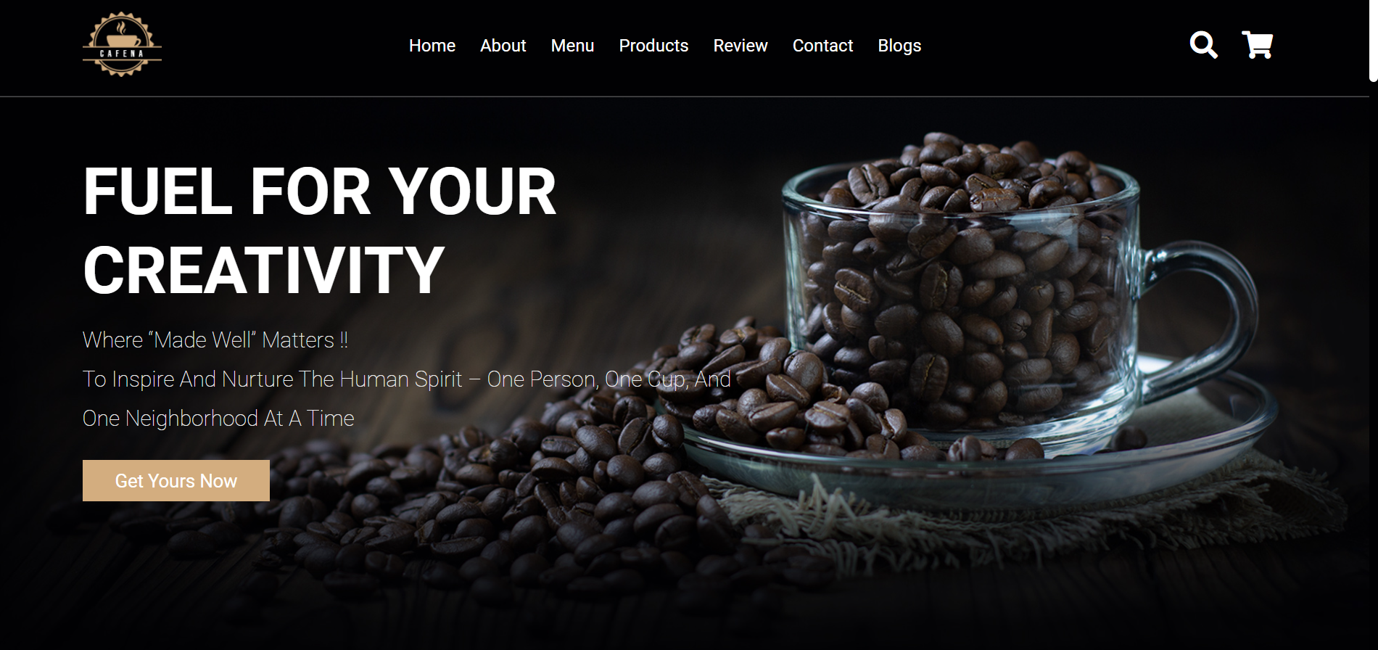

**“ABOUT US”**

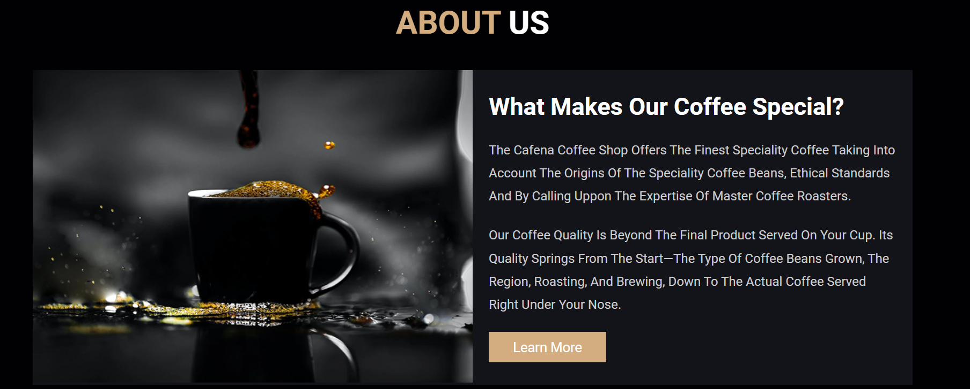

**“MENU”**

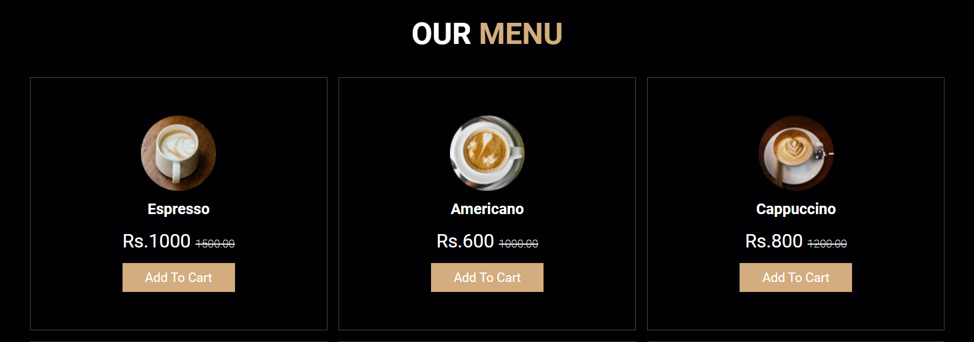

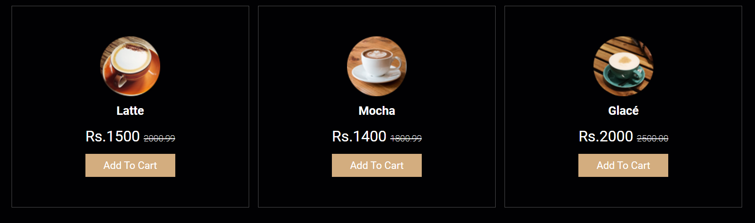

**“PRODUCTS”**

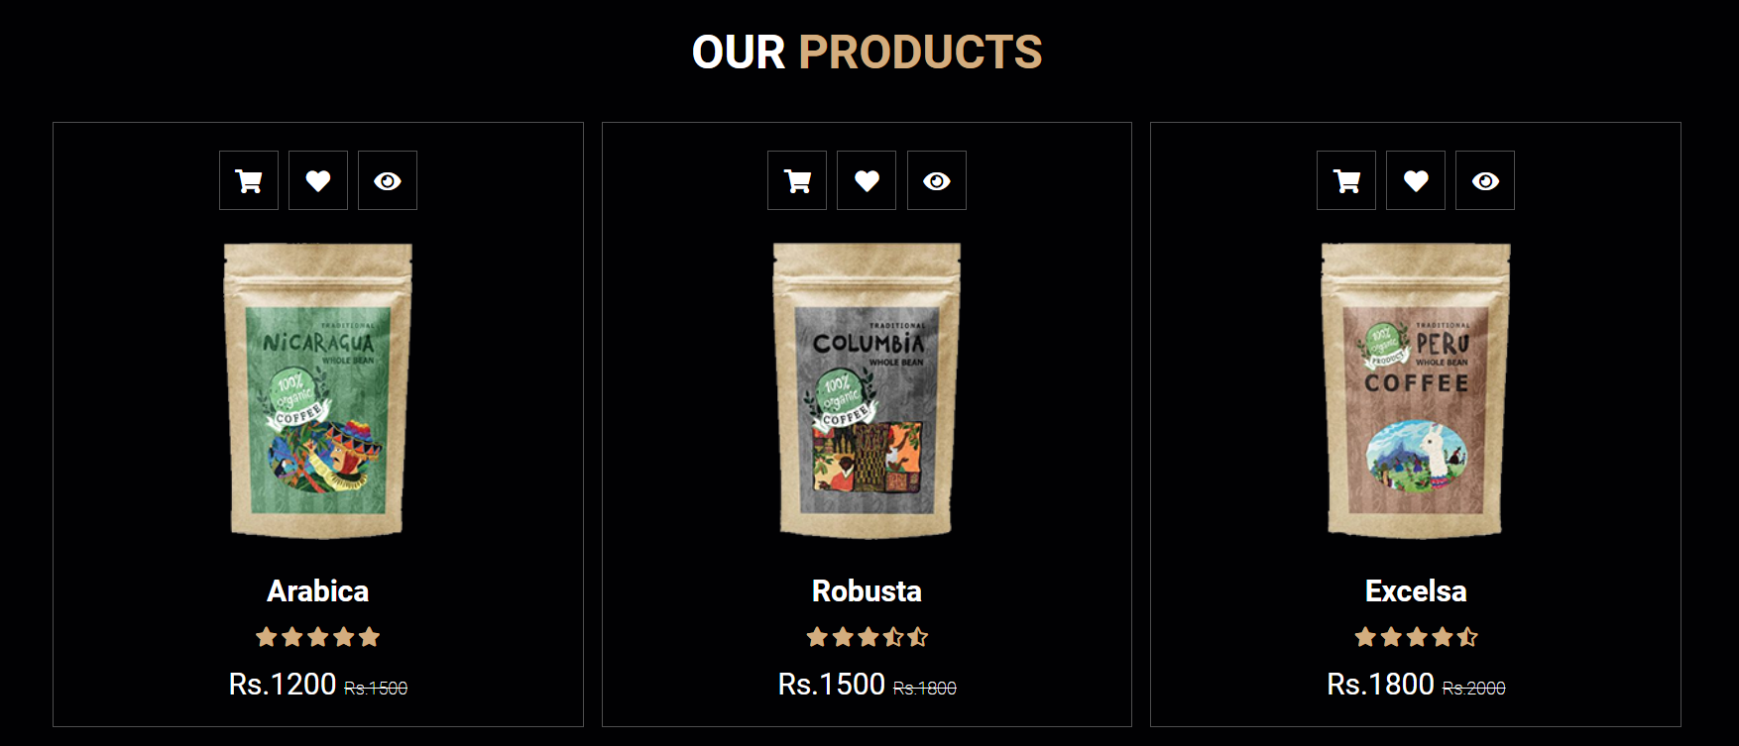

**“REVIEW SECTION”**

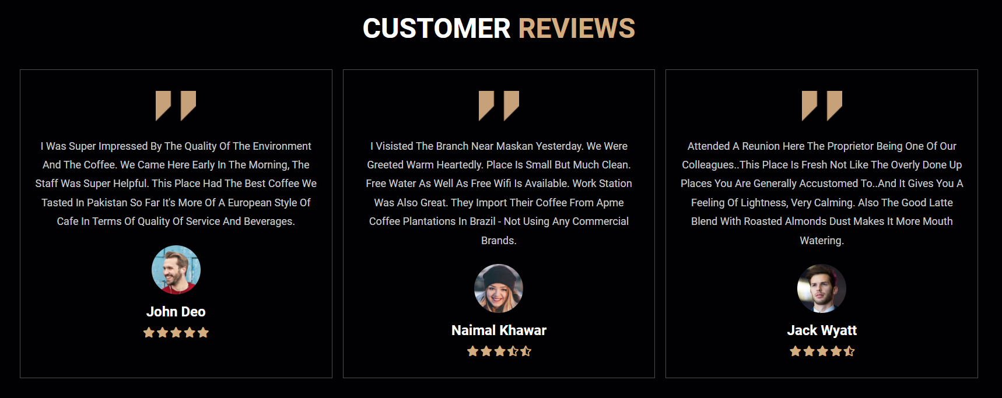

**“CONTACT DETAILS”**

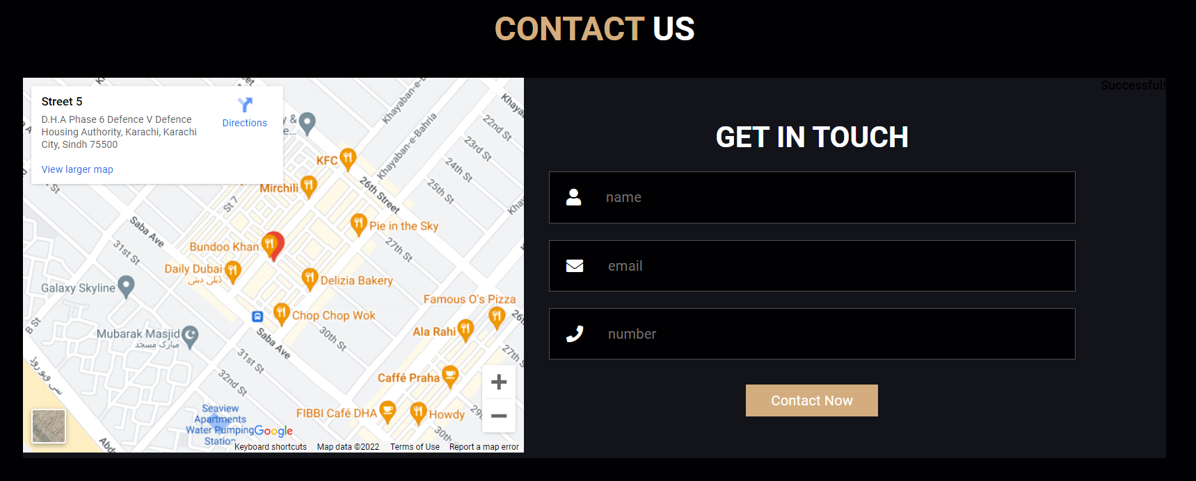

**“BLOGS”**

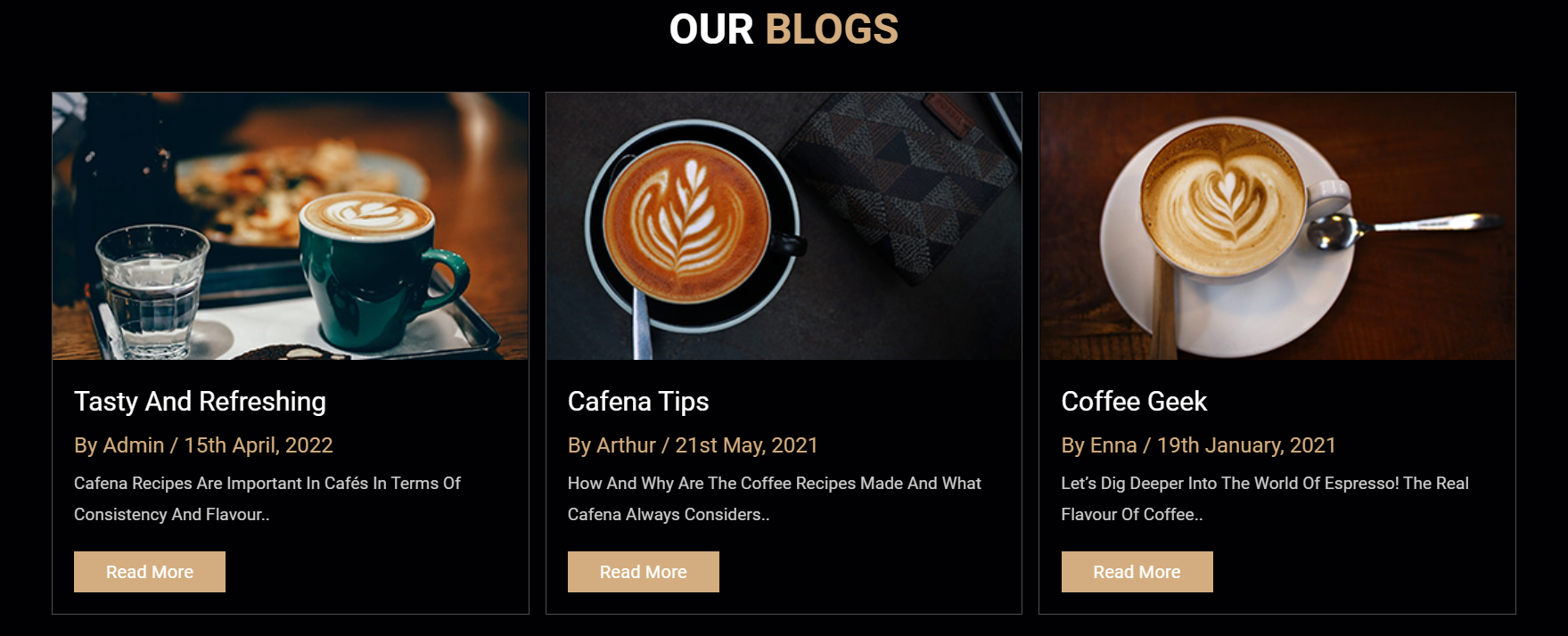

**“FOOTER SECTION”**



**“RESPONSIVENESS”**

